1. **PURPOSE:**

To provide a procedure For Operation and calibration of Agilent 1260 infinity series HPLC.

1. **SCOPE:**

This procedure is applicable to the HPLC following in Quality Control laboratory.

**Make**  : Agilent Technologies

**Model** : 1260 infinity series

**Instrument** **ID No.** : DIPL/QC/INS/HPLC/004.

1. **RESPONSIBILITY:**
   1. Analyst-QC shall be responsible to follow this SOP.
   2. Head-QC/Designee shall be responsible for ensuring implementation of this SOP.
   3. Head-QA/Designee shall be responsible for monitoring overall compliance of this SOP.
2. **DEFINITIONS:**

Nil

1. **PROCEDURE:**
   1. **Operation:**
      1. Check that the instrument is clean and free from dust, if not clean with a soft cloth duster
   2. The LC-1260 infinity series HPLC work station consist of :
      1. Quaternary pump
      2. Thermostat Ted column compartment
      3. Rheodyne injector-20µl
      4. Variable wavelength detector
      5. Computer with windows based HPLC Openlab-Ezchrome elite software
   3. **Basic Operation**
      1. Ensure that the system is connected to stabilized power supply.
      2. Put on the main switch of the instrument. Identify the column to be used for analysis enter the column details in to the edit column.
      3. Connect the prescribed column in the right direction; connect the tubing from the injector to one end of the column and other end to the tugging towards the detector.
   4. **Creating initial admin user:**
      1. 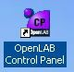 Double click on the **Openlab control panel**.
      2. Click Administration in the navigation pane and select System Configuration.

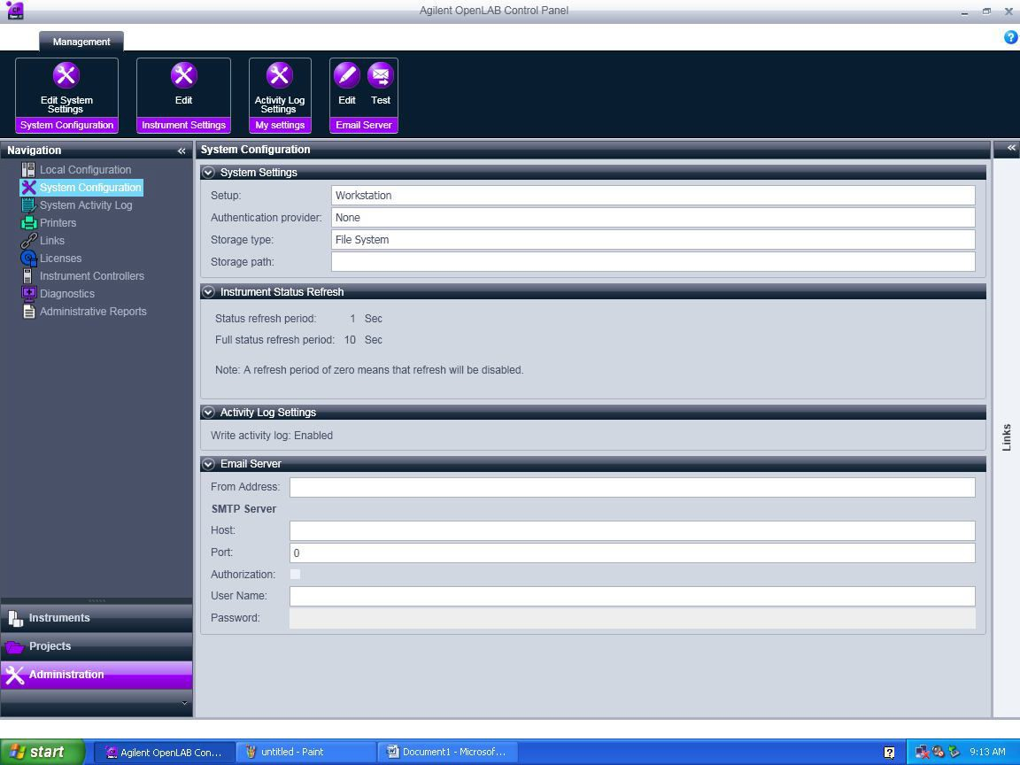

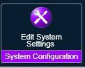Click on Edit system settings

* + 1. The below screen will appear. In the first scroll bar select internal and click Next

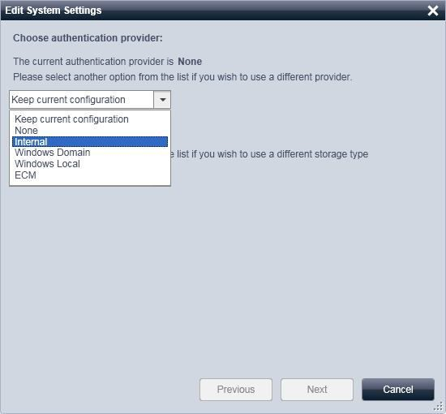

* + 1. The below screen appear. Click on Create Account.

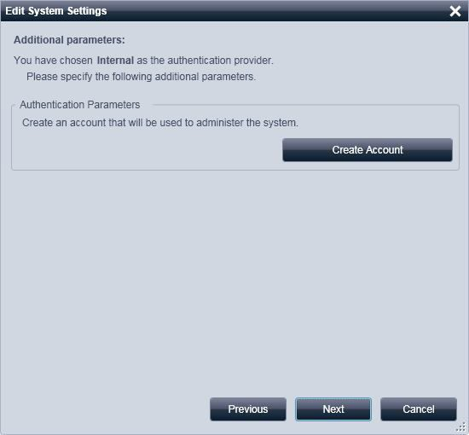

* + 1. Create Administrator Account window will appear. Enter User Name, Full Name, Password and confirm Password details and click OK. ( ** Note: Initial Admin user is must to enable security policy’s and user creation options in the control panel)

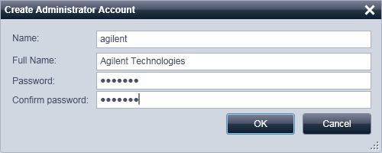

* + 1. Below screen will appear. Click Next

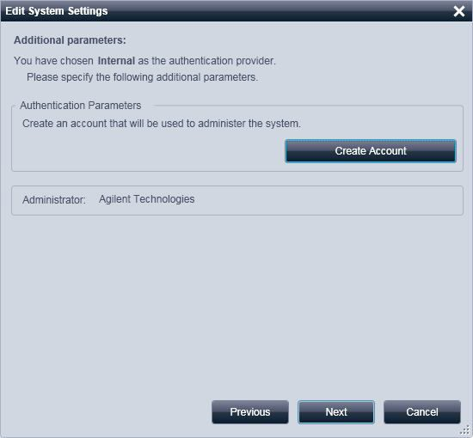

* + 1. Below screen will appear. Click on apply and OK in the next screen, it will close and restart the control panel with user credential options.

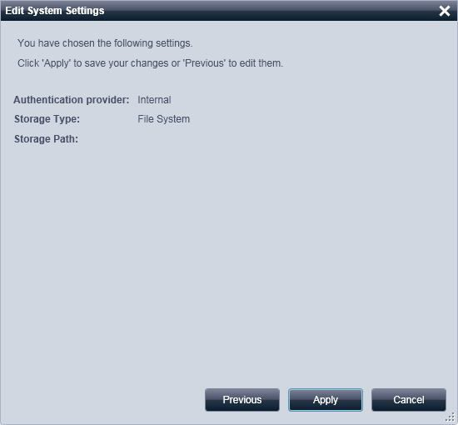

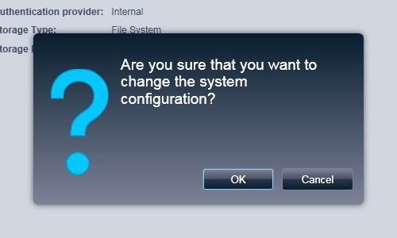

* + 1. Enter the created Admin user and password and click OK.

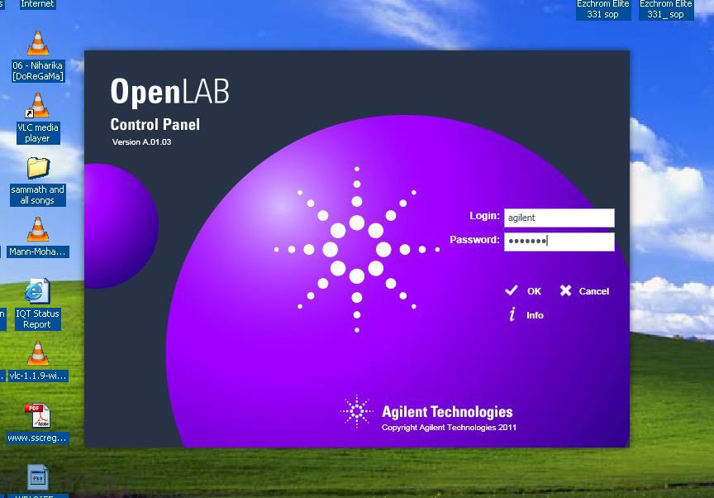

* + 1. Control Panel window will open with enabled Security policy and users Options

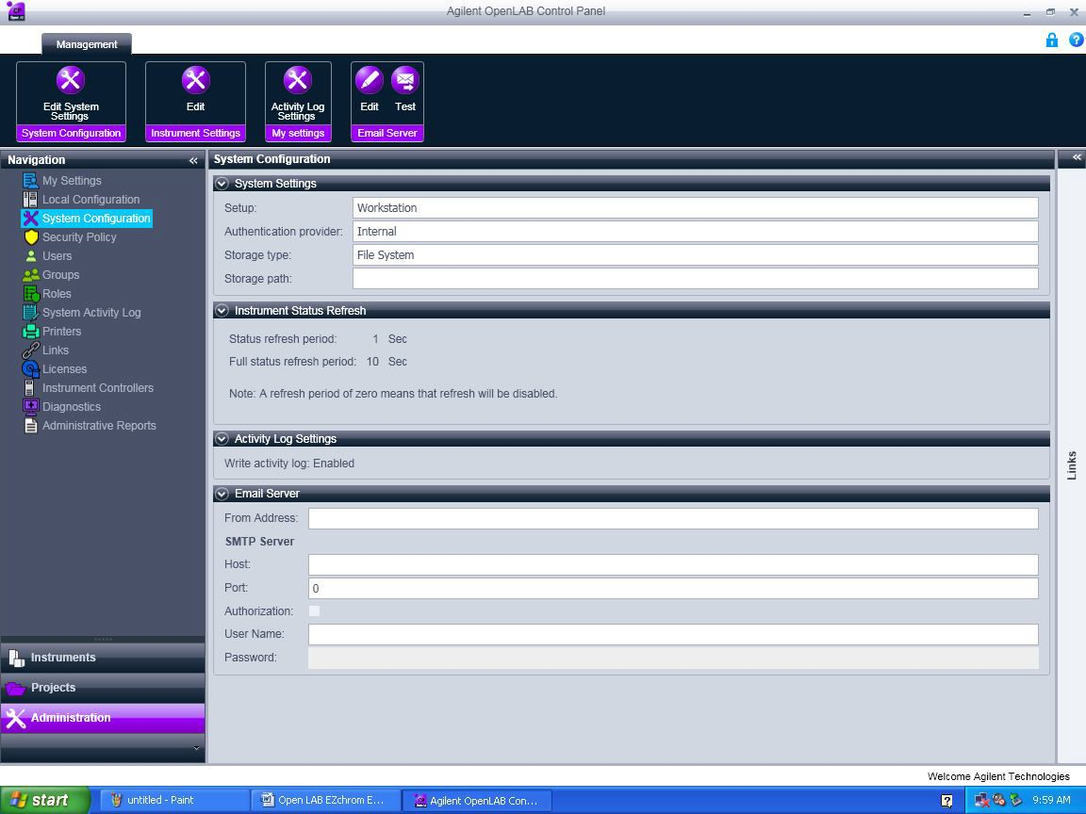

* + 1. Click Administration -> Security Policy -> Click Edit 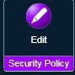 and edit Minimum password length and Password expiration period (days) if required.
    2. To create users click Administration and click on users -> click create  and follow the screen.

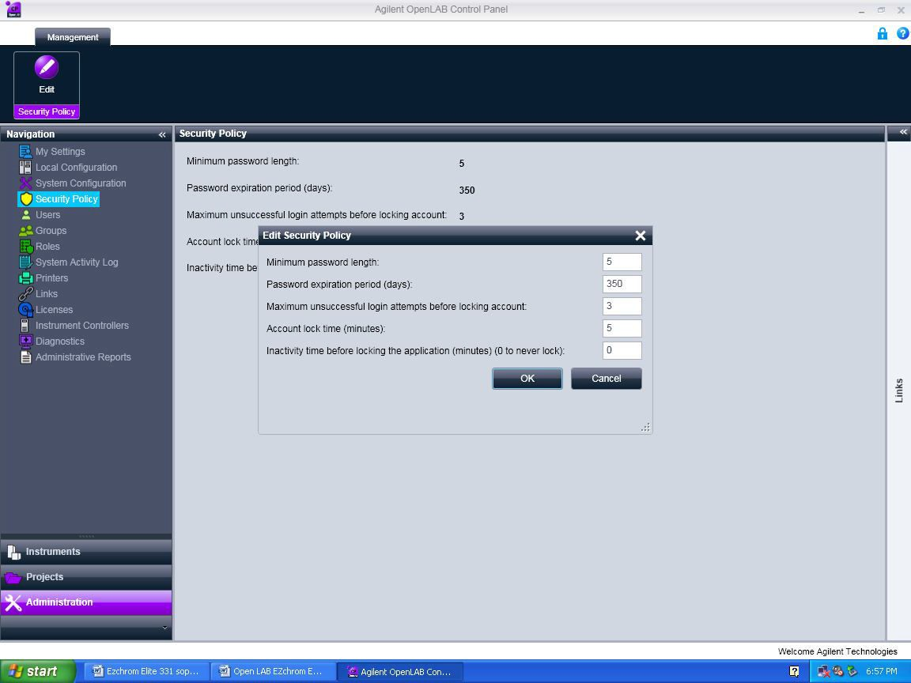

* 1. **Creating data storage path**
     1. Create a Data folder (EX: “Projects” folder or “EZDATA” folder) in C drive or D drive.
     2. In Administration pane click on System Configuration -> Edit System setting and in the second scroll window select File System and click Next.

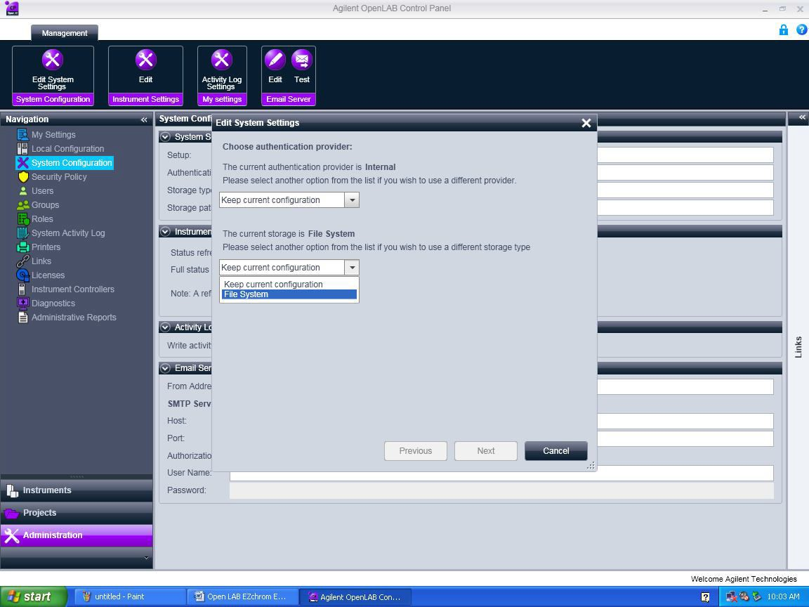

* + 1. The below screen will appear. Browse the data folder (Ex: projects folder) which is already created in the C drive or D drive. Select the created folder and click OK.

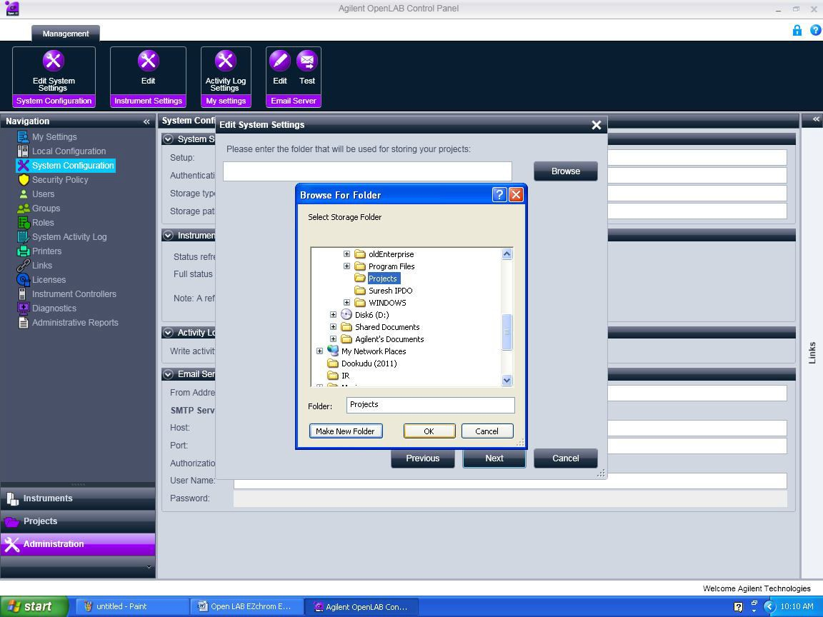

* + 1. Below screen will appear. Click on Next and Apply in the next screen and click OK in the following window. It will close and restart the control panel.

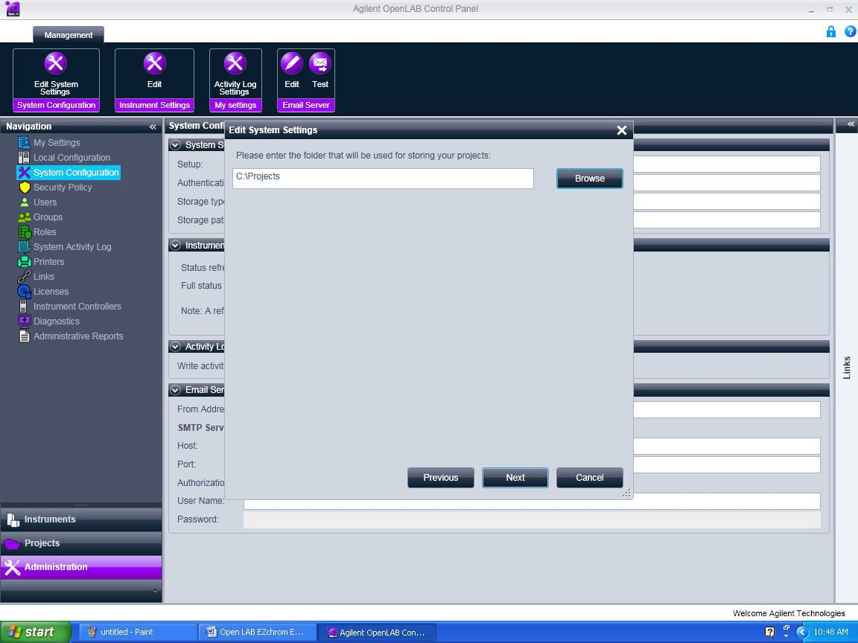



* 1. **How to Crate Project:**
     1. Click on Projects in the navigation pane and click on Create  -> click on Create Project.

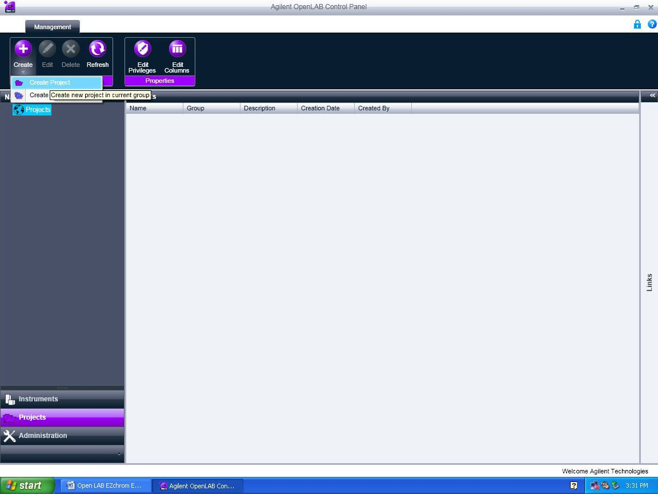

* + 1. In the below screen enter Project Name (Ex. Demo) and project Description -> Click on EZChrom.

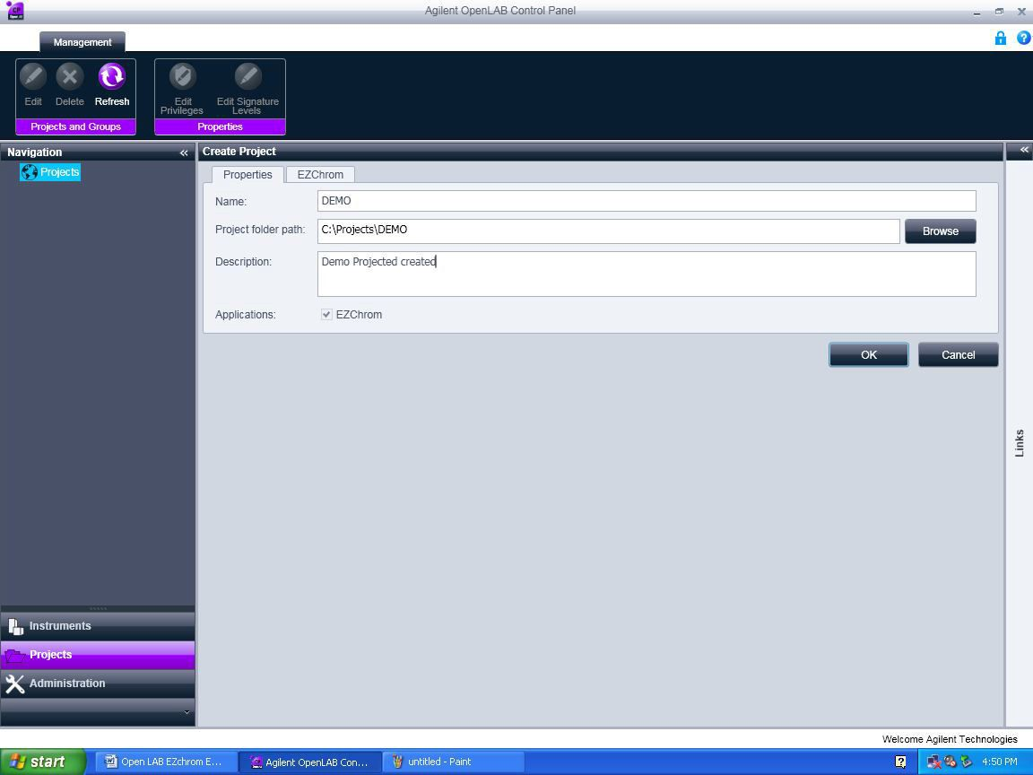

* + 1. The below screen will appear. In Project Options Select the checkboxes for Save all analysis result in data file.
    2. In Result Set Mode select Result Package Mode and select the below two options as shown in the screen shot.
  + Include Method and Sample Prep files in Result Package.
  + Include Report Template files in Result Package.

**\*\* *Don’t Select the Update Original Methods during acquisition with analysis updates***

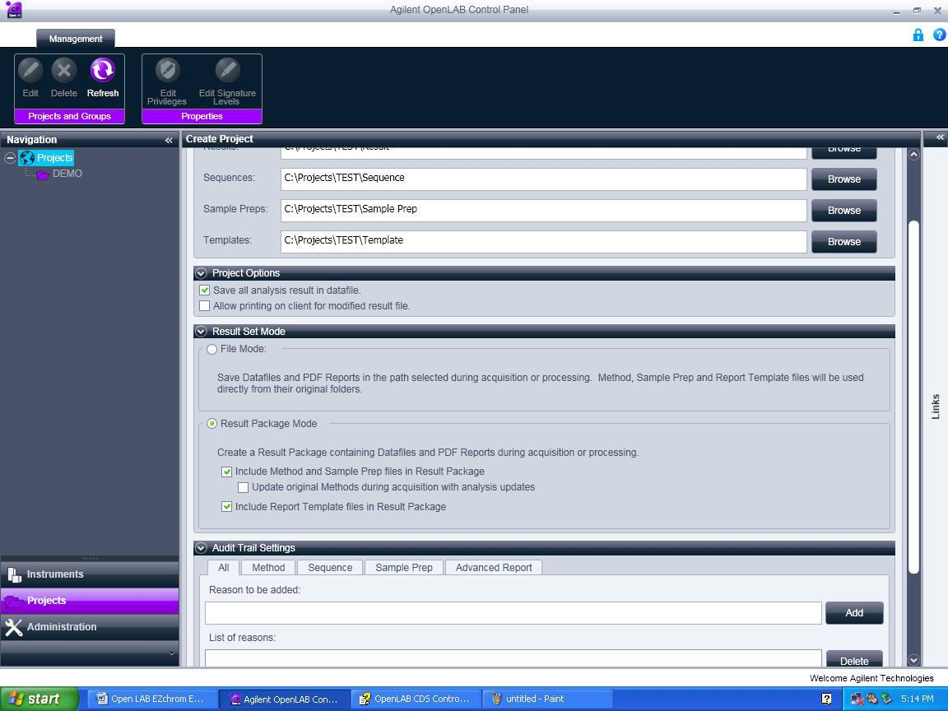

* + 1. Enable Audit Trials in the Audit Trial Setting window. When finished click Ok.

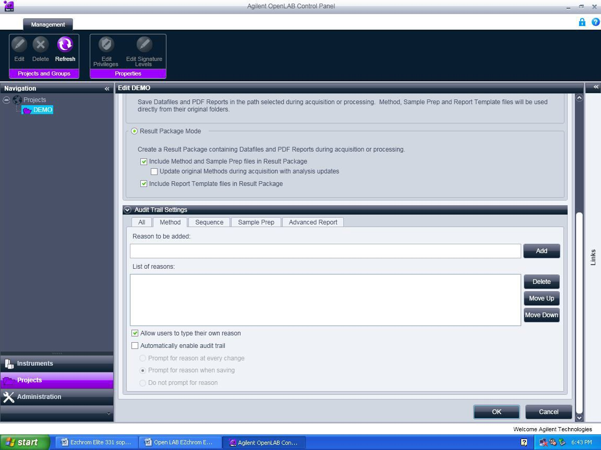

* 1. **Create Method** 
     1. Double click on the Open LAB Control Panel icon. 
     2. Enter the Use ID and Password and click ok.

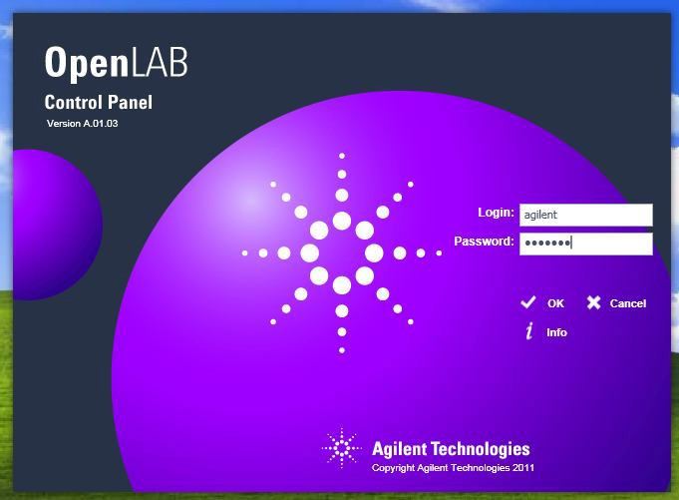

* + 1. Select the Instrument (HPLC) in the navigation (instruments) pane and browse to select the required project and click Launch for online and Launch offline for offline.

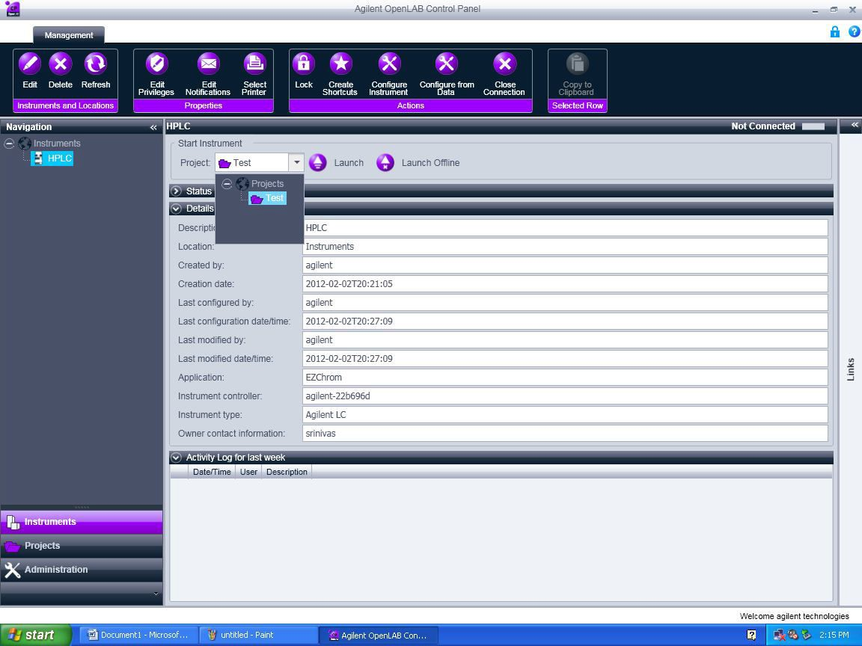

* + 1. Close the instrument wizard window.

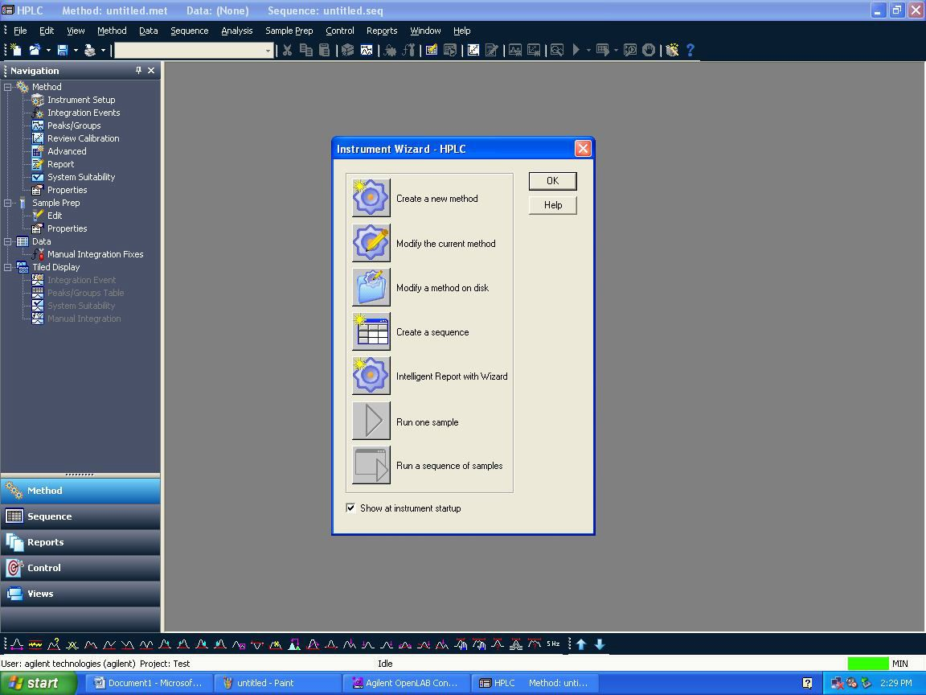

* + 1. Click file > New > and select Blank.met in New file Template and click ok. It will load the Instrument setup window

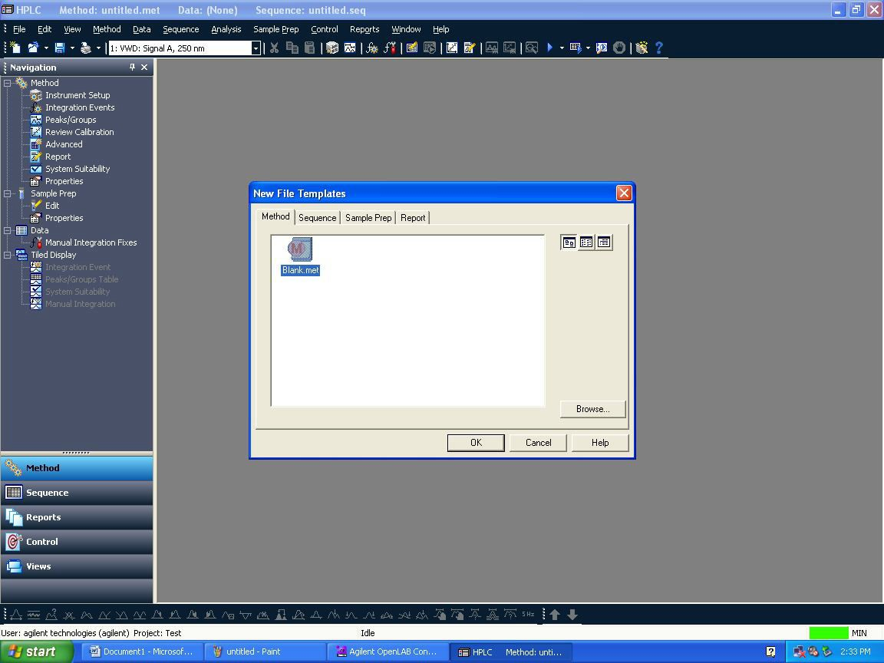

* + 1. Select each module and enter the method parameters as per method spec.
* **Detector:**

Enter wavelength nm – Peak width 0.1 - stop time should be as Pump/ injector.

* **Column Comp:**

Enter the temperature in the Left and select combined in the Right – stop time should be as Pump/ Injector.

* **Quat. Pump:**

Enter flow rate and select the initial solvent composition ( B or C or D) in the solvents – Enter the stop time in the pump. In the right side Timetable check the function centric view box and change the Gradient compositions.

* **Trigger:**

It should be external always.

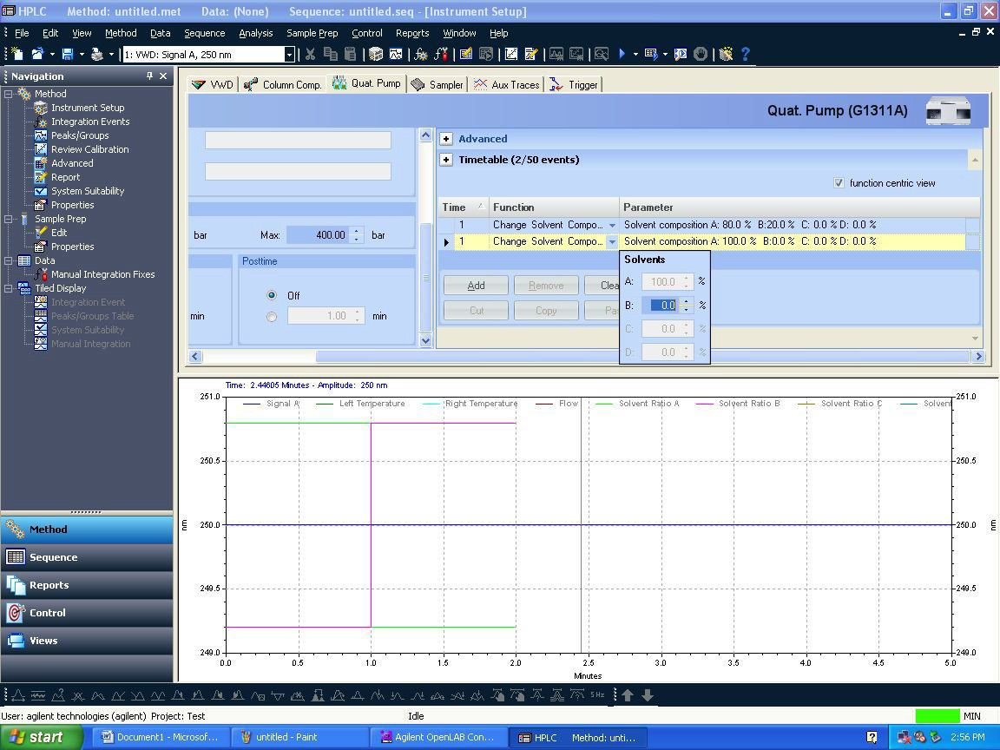

* + 1. After editing all the method parameters, you need to save the method by clicking File-> Save As-> Method

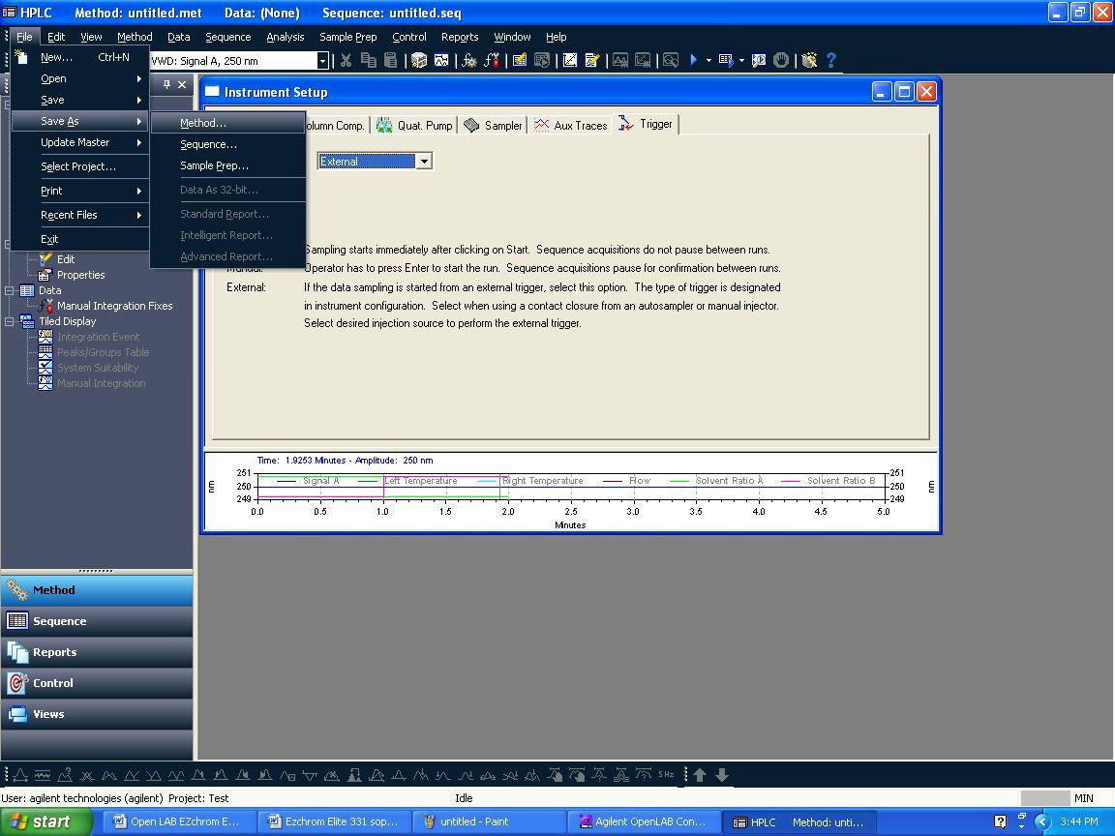

* + 1. Save method screen will appear. Give Method file name in blank space and click save.

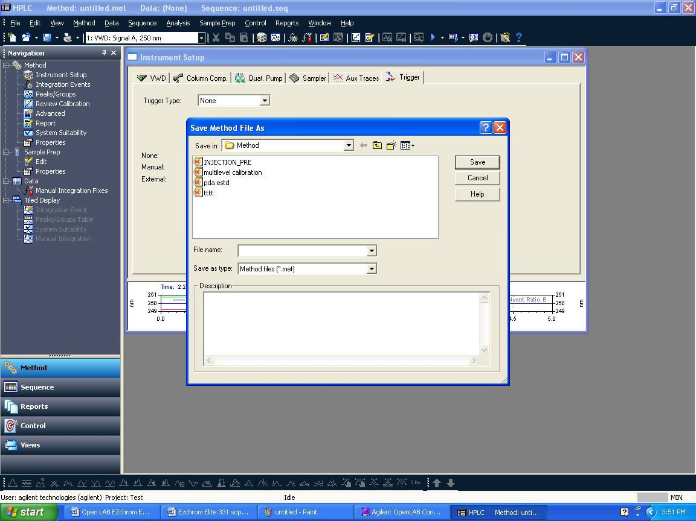

* + 1. After saving method file, down load it into instrument by clicking Control →Download method

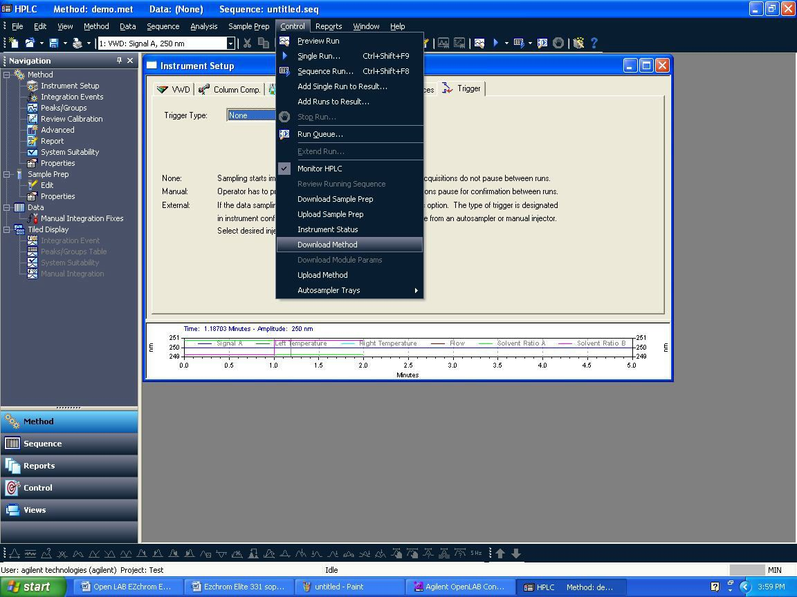

* + 1. After downloading the method, you can see online signal before injection i.e. to check baseline gets stabilize or not. Click On View →Online signal.

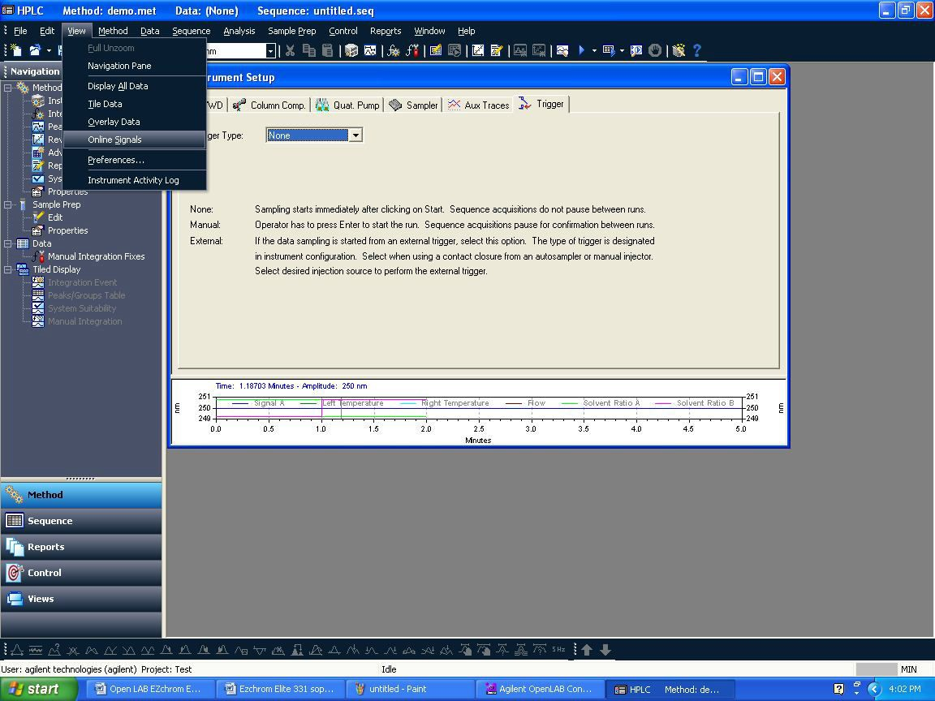

* 1. **How to do single run acquisition:**
     1. Click on Control→Single Run. One window will appear and in that need to enter sample ID, Data file name, Result set name, Vial number and injection volume.

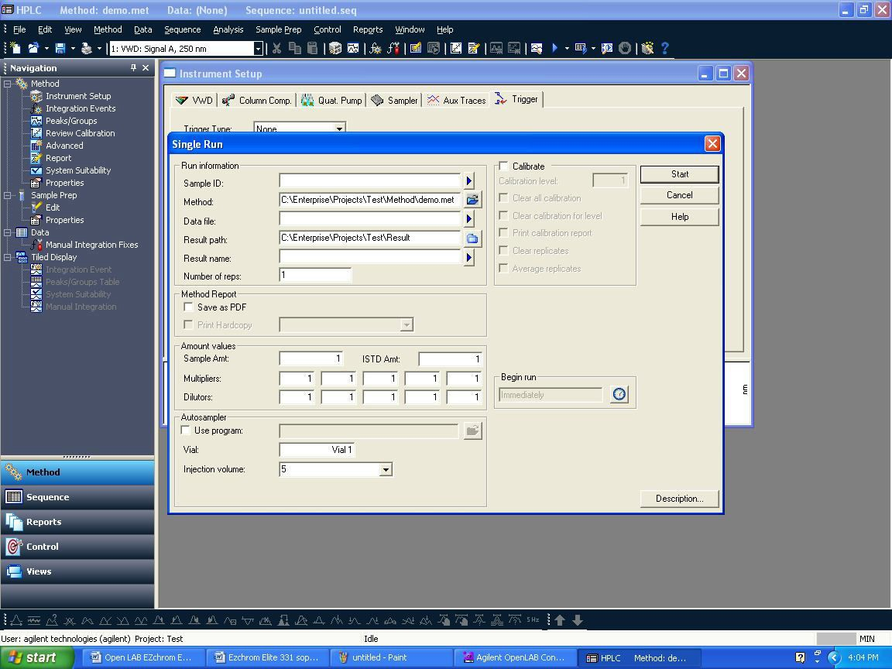

* + 1. Enter sample ID, Data path (browse your path if required), Data file name. In Sample ID and Data file name by clicking triangle symbol , you will be able to give different styles of naming sample ID and data file. Here let select **Increment number**. Give Number of unknown runs in sequence (i.e.: no. of lines you want to create in sequence, for exp. give: 10). Also you can give repetitions per run.
    2. After filling detail in below window, click on **Next.**

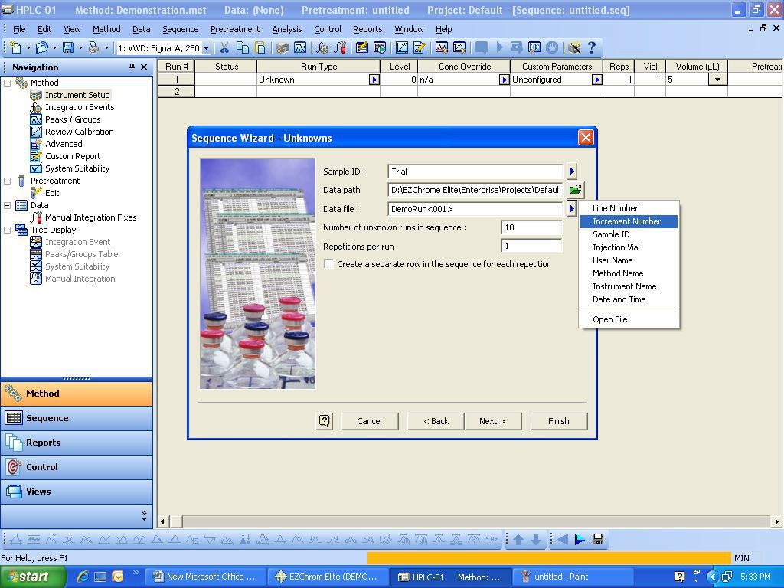

* + 1. The below screen will appear. Browse and select the running Result name by clicking on  the running sequence name will come automatically. After this, just click on Submit and this will run the added lines in the sequence and the data will be saved in the running Result Set.

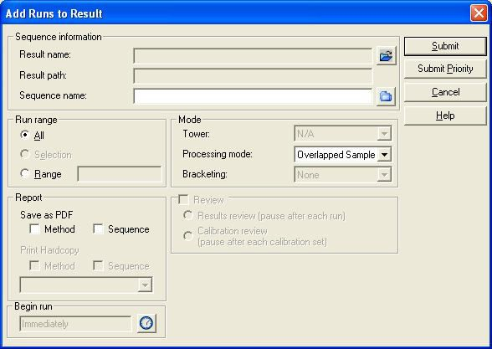

* + 1. After completing the single run the below Results Review Mode screen will appear. In this mode you cannot change or edit the instrument parameter like flow etc. So to access the instrument parameters, click control -> Monitor HPLC.

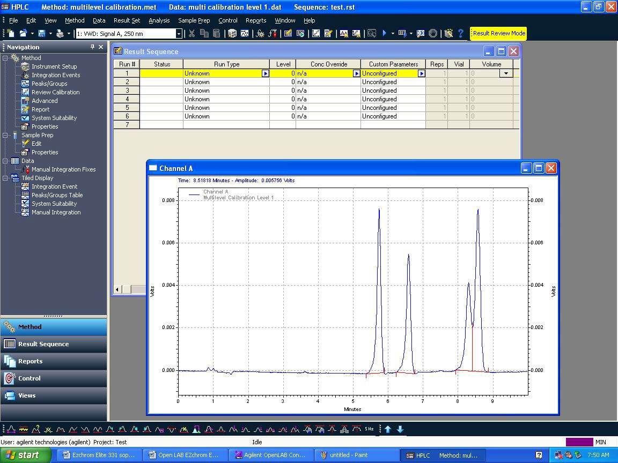

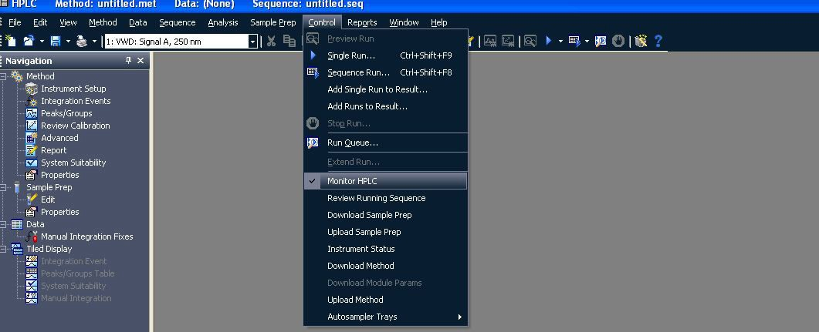

* 1. **How to access acquired data integrate data, assign peak name, process sequence:**
     1. In the Control Panel -> Select Instrument -> select the project -> click on Launch Offline.

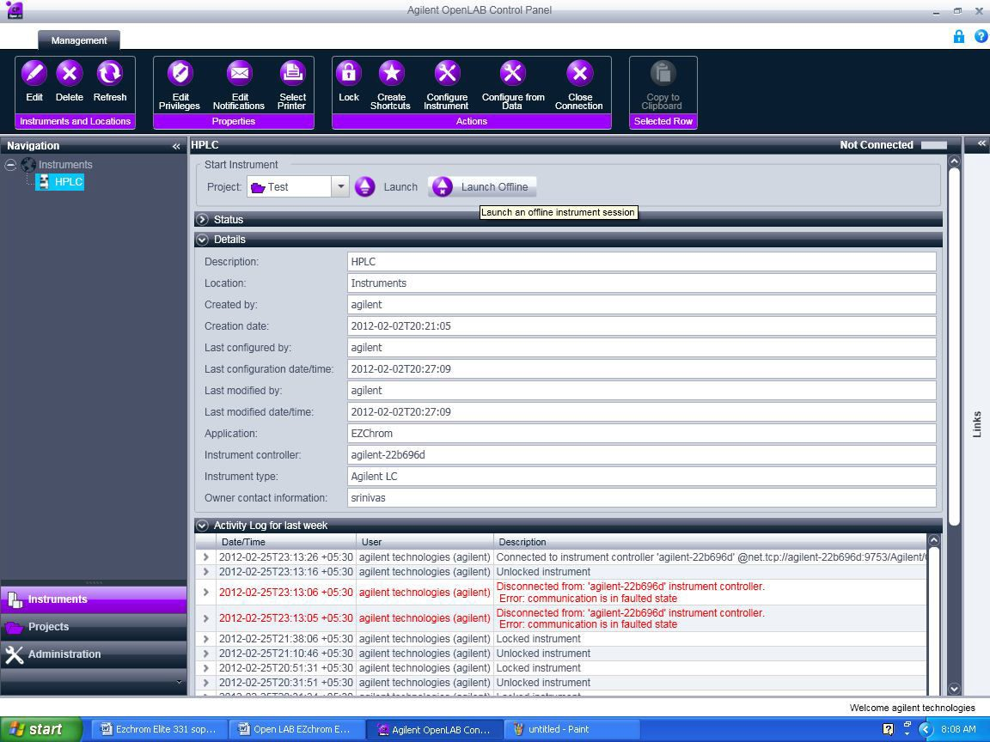

* + 1. The below screen will appear and close the instrument Wizard.

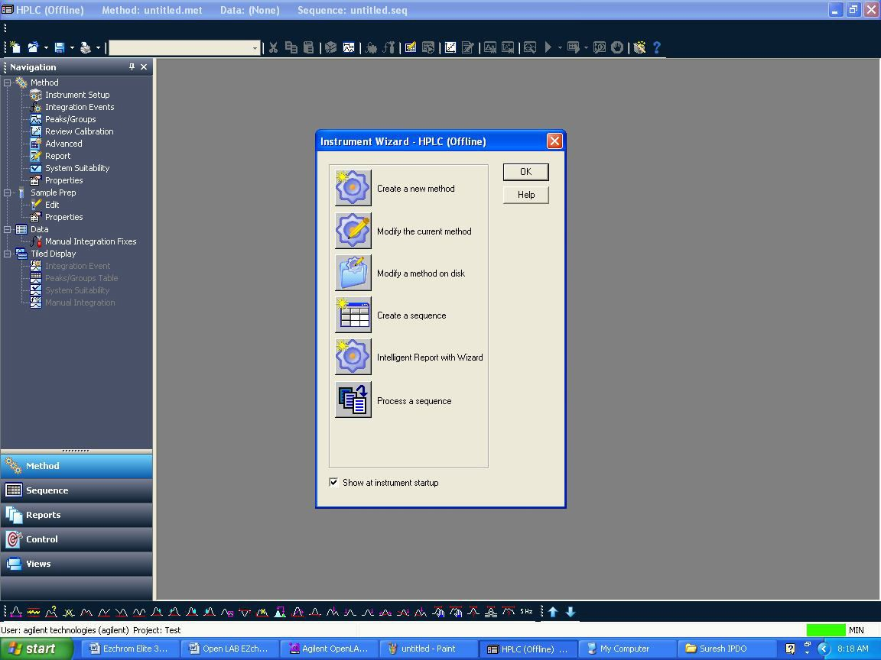

* + 1. Click File -> Open -> Result Set…

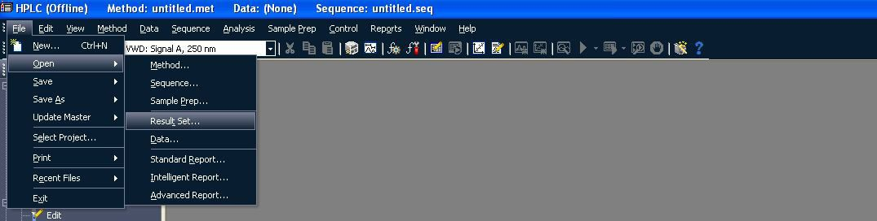

* + 1. The below window will appear and select the required Result Set and click on Open

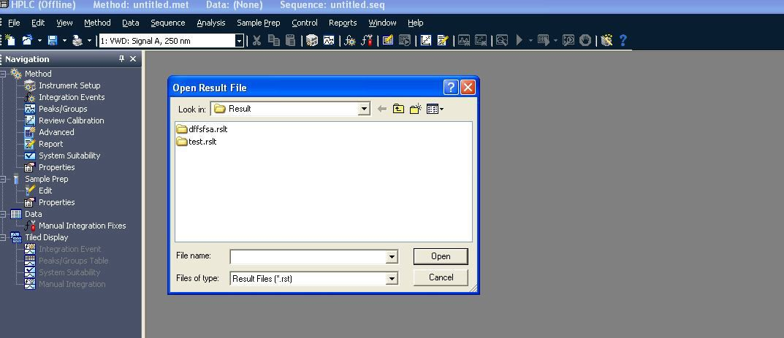

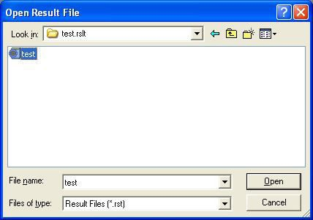

* + 1. The below screen will appear once you click Open. The Result Set will be opened along the Method.

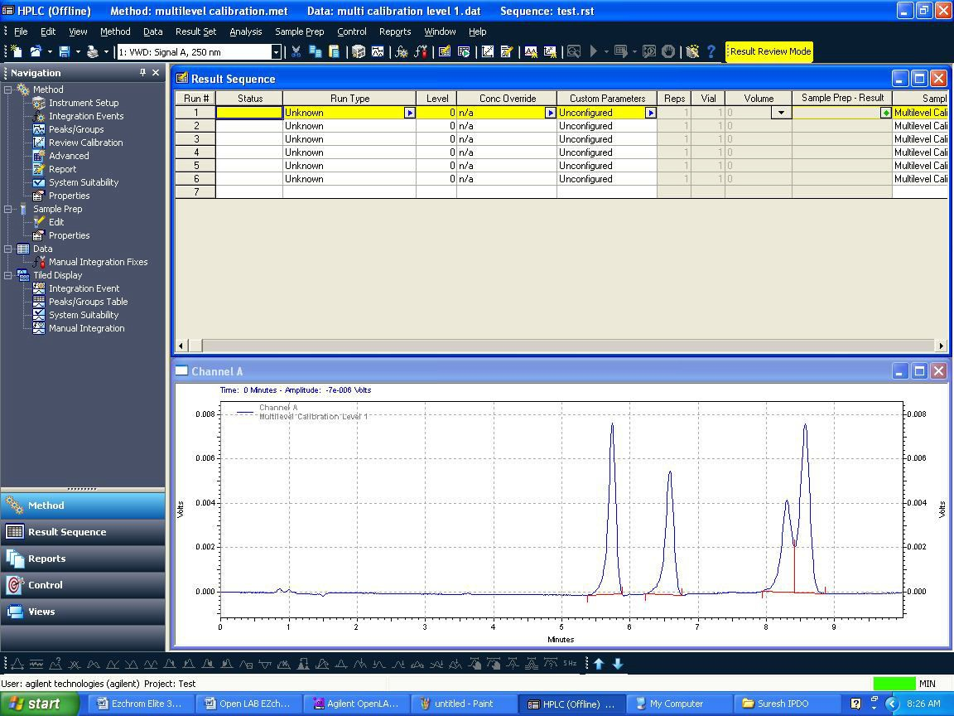

* + 1. To open a data just right click on any line and click on Select Record it will open the data file OR just double click on any line it will open the data file.

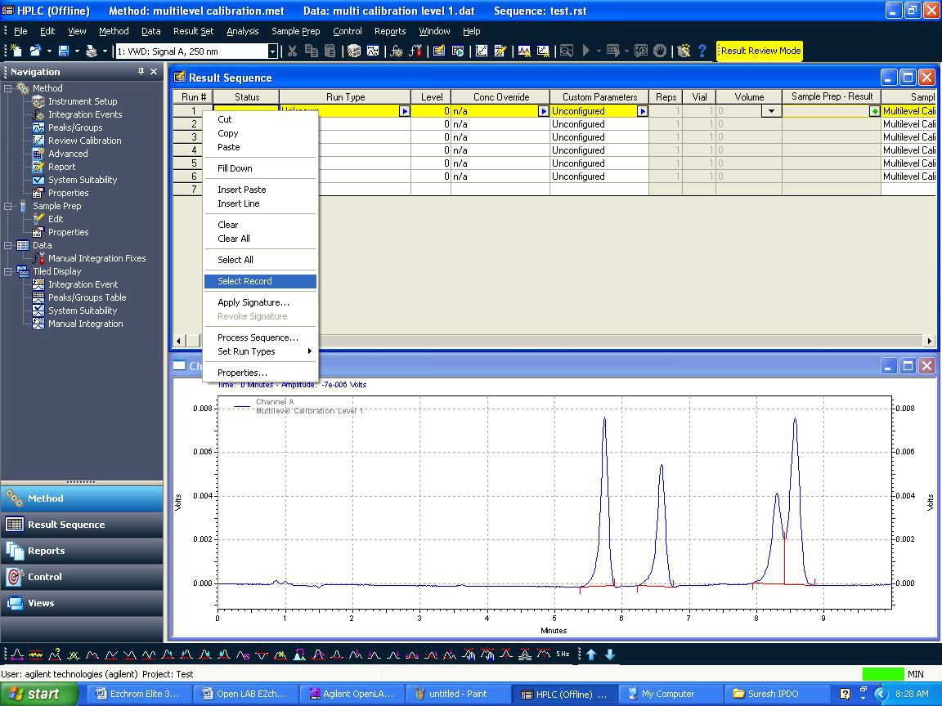

* + 1. To integrate chromatogram, integration events are available.
    2. By right click on chromatogram →Graphical Programming →list will be displayed, from that you can use different integration events like integration off, valley to valley etc.

**OR**

* + 1. You can integrate chromatogram using graphical tools i.e. available at the bottom in the same window.

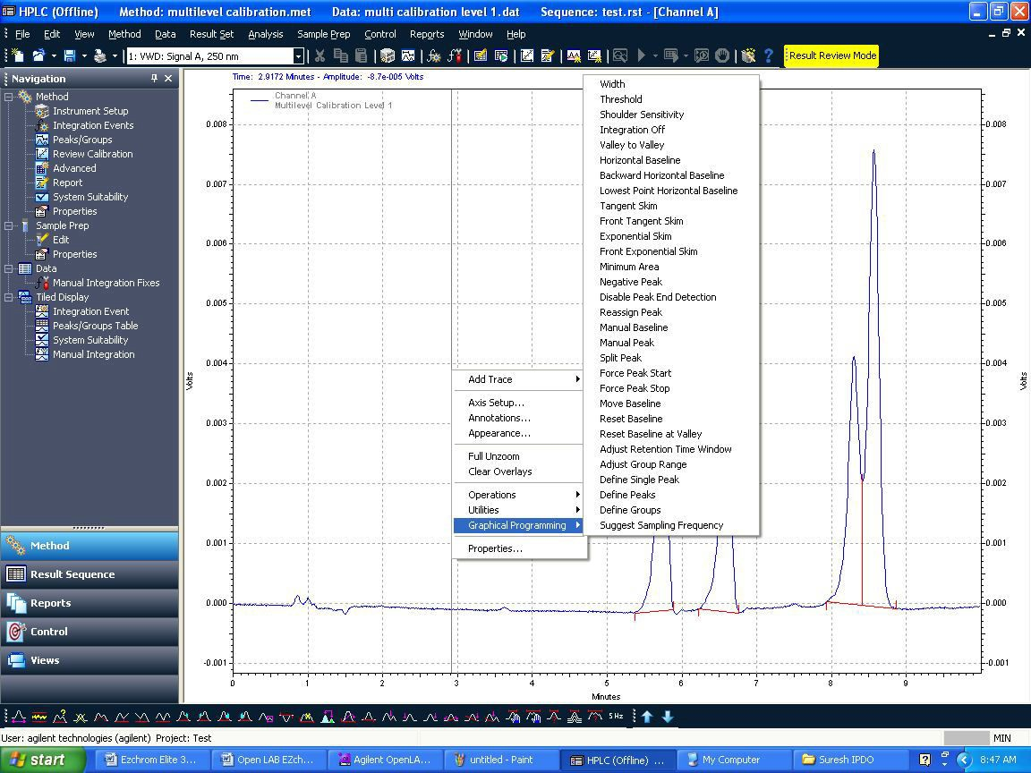

* + 1. If you integrate by using graphical tool, the below screen will appear with integration parameter and in the same window you will be asked to select two options,
    2. Option-1: “Add event to Method (all data)”
    3. Option-2: “Applicable for all the data files.
    4. And if you select Option-2, only the particular the data which is open will be integrated. Add event to the data file only”.
    5. Here if you select Option-1, the events will be added to method.

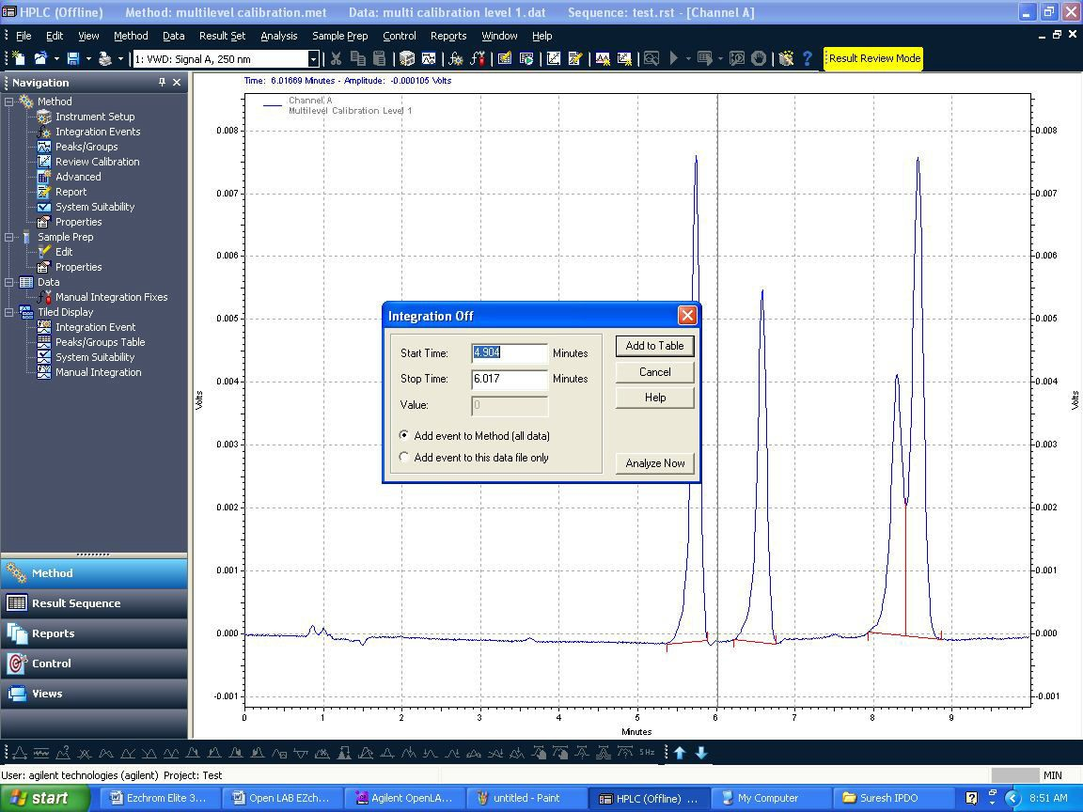

* 1. **Calibration:**
  2. **Calibration Schedule : Every 4 months**

| **S.No** | **Name of the Test** | **Acceptance criteria** | |
| --- | --- | --- | --- |
| 01 | Calibration of Pump | | |
| Flow accuracy | | |
| 1) For flow 0.50 mL/min | Between 0.475 mL and 0.525 mL | |
| 2) For flow 1.00 mL/min | Between 0.95 mL and 1.05 mL | |
| 3) For flow 2.00 mL/min | Between 1.90 mL and 2.10 mL | |
| 02 | Gradient accuracy | 1. At B concentration 10% level actual concentration should be between 9.0% and 11.0%. 2. At B concentration 50% level actual concentration should be between 49.0% and 51.0% 3. At B concentration 90% level actual concentration should be between 89.0% and 91.0%. | |
| 03 | Column compartment thermostat/ oven calibration & | The difference between the set temperature and the displayed temperature on the digital thermometer and instrument should not be more than ± 2.0°C. | |
| 04 | Detector Lamp Intensity | | |
|  | For VWD Detector | **INTENSITY LIMIT:**  Range: Limit in counts (NLT)  Highest intensity > 320000  Average intensity > 160000  Lowest intensity > 6400 | |
| 05 | Wavelength accuracy | Standard Absorbance Maxima/minima | Limit |
|  | a) By using caffeine | 205 nm  245 nm  273 nm | 203 nm to 207 nm  243 nm to 247 nm  271 nm to 275 nm |
| 06 | Precision for injector | 1. The % RSD of peak areas of Caffeine from the 5 replicate injections at 20µL level should be less than 2.0 | |
| 07 | Precision and Linearity of Detector. | 1) The % RSD for the RT of caffeine from the five  replicate injections at each level should be less than 1.0   1. The % RSD of peak areas of Caffeine from the 5   replicate injections at each level should be less than 2.0   1. The linearity coefficient ‘r’ for different levels should   not be less than 0.999. | |

* + 1. **Calibration of Pump :**
* Disconnect any column if connected to the system and connect the restriction capillary of 2 m x 0.12 mm ID dimension Purge the system initially with suitable solvent and then with purified water to remove any solvents or buffer salts.
* Keep channel A in filtered and degassed purified water .Set the flow at 0.50 mL per minute. Keep the system at this flow rate for about 10 minutes to equilibrate the system.
* Collect the volume of water in volumetric flaks delivered for 20 minutes using stop watch and determine the weight of the water weight.
* Convert the weight of the water obtained volume, in mL by the following formula $$Actual flow=\frac{Collected water weight}{Collected time in\min{×0.99602}}$$

**Note:** *density of water at 25ºC is 0.99602gr

Reference IP-2007 of Volumne-1 Page 165

* Repeat the above for 1.00 and 2.00 flow rates.
* Acceptance criteria:

Flow accuracy: For the set flow rate (Between 95% and 105%)

For flow 0.50 mL/min: - Between 0.475 mL and 0.525 mL

For flow 1.00 mL/min: - Between 0.95 mL and 1.05 ml

For flow 2.00 mL/min: - Between 1.90 mL and 2.10 mL

* + 1. **Gradient accuracy:**
* **Chromatographic Condition:**

|  |  |  |
| --- | --- | --- |
| Column | **:** | Restriction Capillary |
| Detector wavelength | **:** | 254nm |
| Injection volume | **:** | 20 µl |
| Flow rate | **:** | 2.0ml/minute |
| Runtime | **:** | 30 minutes |
| Mobile Phase | **:** | Mobile Phase-A: Analytical water  Mobile Phase-B:  0.3% v/v acetone in filtered analytical water  (1ml of acetone in 1000ml of water) |

Gradient Programme:

| **Time (min)** | **Mobile phase B percentage** |
| --- | --- |
| 0.01 | 0 |
| 2.00 | 0 |
| 2.01 | 10 |
| 8.00 | 10 |
| 8.01 | 50 |
| 13.00 | 50 |
| 13.01 | 90 |
| 18.00 | 90 |
| 18.01 | 100 |
| 23.00 | 100 |
| 23.01 | 0 |
| 30.00 | 0 |

* **Procedure:**

Open the drain valves and purge the flow lines of both pumps. Equilibrate the column with initial concentration with above mentioned conditions and wait until the baseline is stable Adjust the baseline level to fit the full Scale of the integrator. Inject exactly 20 µL of mobile phase A and start the time program for gradient accuracy test.

Determine the signal level at 0% (B Con),10% (B Con), 50% (B Con), 90% (B Con) and 100% (B Con)

Calculate the actual B concentration level at 10% (B Con), 50% (B Con), 90% (B Con) Using 0% (B Con) and 100% (B Con).

* **Calculation:**

Calculate the actual B concentration level at 10**%**

$$=\frac{B concentration level at 10\% - B concentration level at 0\% x 100}{B concentration level at 100\% - B concentration level at 0\%}$$

Similarly calculate the actual B concentration level at 50% (B Con) and 90% (B Con) Follow the Procedure exactly using C&D channels instead of A&B.

* **Acceptance *Criteria:***

**For pump A&B**

At B concentration 10 %level actual concentration should be between 9.0% and 11.0%.

At B concentration 50% level actual concentration should be between 49.0% and 51.0%.

At B concentration 90% level actual concentration should be between 89.0% and 91.0%.

**For pump C&D**

At D concentration 10% level actual concentration should be between 9.0% and 11.0%.

At D concentration 50% level actual concentration should be between 49.0% and 51.0

At D concentration 90% level actual concentration should be between 89.0% and 91.0%.

* + 1. **Column compartment thermostat / oven calibration:**
* Disconnect any column if connected to the system.
* Purge the system with Purified water to remove any solvents and previous buffer salts.
* Connect a restriction capillary of dimension 2m x 0.12 mm ID in place of column
* Keep a flow rate of 1.0 mL/minute.
* Keep the sensor wire of the traceable digital thermometer in the right side of the column thermostat/ oven.
* Set the temperature at 20.0°C.Wait till the set temperature is attained and the temperature display on the instrument is stable.
* Wait for 5 minutes before readings are taken so that the temperature on the instrument and that displayed on the thermometer are stable.
* Note down the temperature displayed by the instrument and the thermometer.
* Repeat the for temperature settings at 30.0°C, 40.0°C, 50.0°C, 60.0°C& 70.0°C.
* Shift the thermometer sensor wire to the left side thermostat and repeat the Exercise.
* Ac**ceptance Criteria:**
* The difference between the set temperature and displayed temperature on the instrument and thermometer should be within ± 2.0°C.
  + 1. **Detector Lamp Intensity Check:**
* **For VWD Detector:**
* Pass the purified water for 10 to 15 minutes through the flow cell.
* Click on ‘Lab advisor & Service &Diagnosis software’Lab monitor managementClick on Start monitoring buttonActive Green colour will be displayed.
* Close the Lab monitor management.
* Click on Tests 4 windows appear - pump, ALS, Thermostat and VWD.
* Select ‘VWD’ for intensity test.
* Select intensity test and press run test now.
* Display shows procedures list.
* After 2-3 minutes, lamp intensity spectrum appears on screen.
* **Acceptance Criteria:**

INTENSITY LIMIT:

Range : Limit in counts (NLT)

Highest intensity > 320000

Average intensity > 160000

Lowest intensity > 6400

* + 1. **Wavelength accuracy:**
* By using caffeine:
* **Chromatographic conditions:**

|  |  |  |
| --- | --- | --- |
| Column | **:** | Restriction capillary column |
| Mobile phase | **:** | Acetonitrile: Purified water (15 : 85 v/v).Filter and degas |
| Flow rate | **:** | 1.0mL/min |
| Run time | **:** | 3 minutes |
| Temperature | **:** | 36°C |
| Wavelength | **:** | For Lambda Maximum at 205 nm perform the wavelengths listed 202 nm, 203nm, 204nm, 205nm, 206nm, 207nm, 208nm.  For Lambda Minimum at 245 nm perform the wavelengths listed below 242nm, 243nm, 244nm, 245nm, 246nm, 247 nm, 248 nm.  For Lambda Maximum at 273 nm perform the wavelengths listed below nm, 271nm, 272nm, 273nm, 274nm, 275nm, 276nm |

* **Preparation of standard solution**:

Weigh accurately 25 mg of Caffeine into a 100 mL volumetric flask, dissolve and dilute to volume with water. Further dilute 10 ml to 100 ml with water (25µg/mL). Inject 20uL of the standard solution in different wavelengths and record the chromatograms.

* **Acceptance criteria**:

The wavelengths at which maximum absorbance observed.

|  |  |
| --- | --- |
| Standard | Limit |
| Absorbance Maximum at 205nm | 203nm to 207nm |
| Absorbance Minimum at 245nm | 243nm to 247nm |
| Absorbance Maximum at 273nm | 271nm to 275nm |

* + 1. **Precision for Injector:**
* **Chromatographic conditions:**

|  |  |  |
| --- | --- | --- |
| Column | **:** | Restriction capillary column |
| Mobile phase | **:** | Acetonitrile: Purified water (15: 85 v/v).Filter and degas |
| Flow rate | **:** | 1.5mL/min |
| Run time | **:** | 5 minutes |
| Wave length | **:** | 273nm |
| Temperature | **:** | 36°C |
| Injection volume | **:** | 20µL |

* **Preparation of standard solution:**

Weigh accurately 25 mg of Caffeine into a 100 mL volumetric flask, dissolve and dilute to volume with mobile phase. Further dilute 10 mL to 100 mL with mobile phase. (25 µg/mL)

* **Procedure:**

Inject 20 µL of the standard solution into the system in five replicates and record the chromatograms.

* **Acceptance criteria:**

The % RSD of peak areas of Caffeine from the 5 replicate injections at 20 µL level should not be less than 2.0.

* + 1. **Precision and Linearity of detector response:**
* **Chromatographic conditions:**

|  |  |  |
| --- | --- | --- |
| Column | **:** | Restriction capillary column |
| Mobile phase | **:** | Acetonitrile: Purified water (15: 85 v/v).Filter and degas |
| Flow rate | **:** | 1.5mL/min |
| Run time | **:** | 5 minutes |
| Wave length | **:** | 273nm |
| Temperature | **:** | 36°C |
| Injection volume | **:** | 20µL |

* **Preparation of standard stock solution:**

Weigh accurately 25 mg of Caffeine into a 100 mL volumetric flask, dissolve and dilute to volume with mobile phase.

* **Preparation of Level-01 standard solution**:

Take 2.0 mL of standard stock solution into a 50 mL volumetric flask, dissolve and dilute to the mark with Mobile Phase.

* **Preparation of Level-02 standard solution**:

Take 4.0 mL of standard stock solution into a 50 mL volumetric flask, dissolve and dilute to the mark with Mobile Phase.

* **Preparation of Level-03 standard solution**:

Take 6.0 mL of standard stock solution into a 50mL volumetric flask, dissolve and dilute to the mark with Mobile Phase.

* **Preparation of Level-04 standard solution:**

Take 8.0 mL of standard stock solution into a 50 mL volumetric flask, dissolve and dilute to the mark with Mobile Phase.

* **Procedure:**
* Inject the 20μL of the Blank and Standard Solution from each level in five replicates and record the chromatograms.
* Calculate the percentage RSD of the peak areas of caffeine from the five replicate injections at each level.
* Calculate the average peak area of caffeine from the five replicate injections at each level.
* Calculate the percentage RSD of retention times of caffeine at each level.
* Plot the linearity graph with concentration of each level on the x- axis against average area of Caffeine at corresponding level on the y-axis
* **Acceptance Criteria:**
* The % RSD for the retention time of caffeine from the five replicate injections at each level should be less than 1.0.
* The % RSD of peak areas of Caffeine from the 5 replicate injections at each level should be less than 2.0
* The linearity coefficient ‘r’ obtained from the linearity graph of caffeine should not be less than 0.999

1. **FORMATS / ANNEXURE(S):**
   1. HPLC Calibration Record : QC046-FM077
2. **CHANGE HISTORY:**

| **Revision No.** | **Effective Date** | **Details of Revision** | **Ref CCF No.** |
| --- | --- | --- | --- |
| 00 | 29.08.2016 | New SOP introduced | -- |
| 01 | 01.01.2017 | SOP format changed make to in line with SOP-QA-001-04 | QC-CRF-025/16 |
| 02 | 26.04.2017 | 1. SOP format changed make to in line with SOP-QA-001-05. 2. In procedure 5.6.5 point enabling of audit trail while creating project is optional. Make it mandatory while creating project. | CCF/GEN/  17014 |